**EXPERIMENT 3**

**PROGRAMS:**

1. **Create a simple HTML “Hello World” Project using AngularJS Framework and apply ng-controller, ng-model and expressions.**

**Code:**

<!DOCTYPE html>

<html ng-app="app">

<head>

<meta charset="utf 8">

</head>

<body>

<h1 ng-controller="HelloWorldCtrl">{{message}}</h1>

<script src="https://code.angularjs.org/1.6.9/angular.js"></script>

<script>

angular.module("app", []).controller("HelloWorldCtrl", function($scope) {

$scope.message="Hello World"

} )

</script>

</body>

</html>

**Output:**

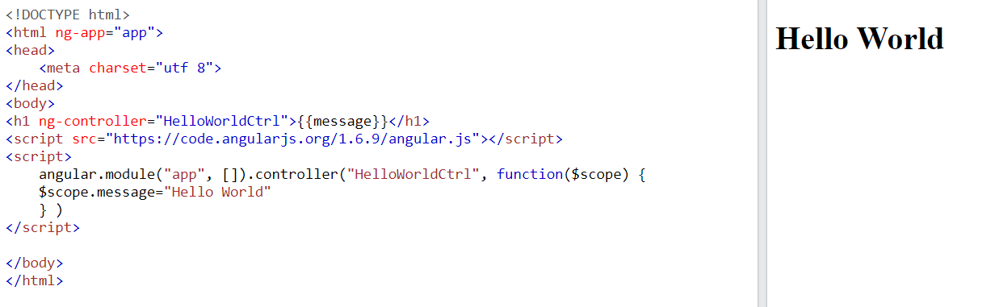

1. **Events and Validations in AngularJS. (Create functions and add events, adding HTML validators, using $valid property of Angular, etc.)**

**Code:**

<!DOCTYPE html>

<html ng-app="app">

<head>

<meta charset="utf 8">

</head>

<body>

<form name="myForm" ng-submit="submitForm()" novalidate>

<label for="name">Name:</label>

<input type="text" id="name" name="name" ng-model="user.name" required>

<br>

<br>

<label for="email">Email:</label>

<input type="email" id="email" name="email" ng-model="user.email" required>

<br>

<br>

<label for="password">Password:</label>

<input type="password" id="password" name="password" ng-model="user.password" ng-minlength="8" required>

<br>

<br>

<button type="submit" ng-disabled="myForm.$invalid">Submit</button>

</form>

<script src="https://code.angularjs.org/1.6.9/angular.js"></script>

<script>

angular.module('myApp', [])

.controller('myController', ['$scope', function($scope) {

$scope.user = {};

$scope.submitForm = function() {

console.log('Submitting form');

console.log($scope.user);

};

}]);

</script>

</body>

</html>

Output:

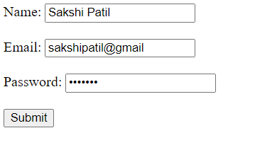

1. **Create an application for like Students Record using AngularJS**

**Code:**

<!DOCTYPE html>

<html>

<head>

<title>Student Registration Form</title>

</head>

<body ng-app="myApp" ng-controller="myController">

<h1>Student Registration</h1>

<form name="registrationForm" novalidate >

<div>

<label for="name">Name:</label>

<input type="text" id="name" name="name" ng-model="newStudent.name" required> <br><br>

<div ng-show="registrationForm.name.$touched && registrationForm.name.$invalid">

<div ng-show="registrationForm.name.$error.required">Name is required.</div>

</div>

</div>

<div>

<label for="email">Email:</label>

<input type="email" id="email" name="email" ng-model="newStudent.email" required> <br><br>

<div ng-show="registrationForm.email.$touched && registrationForm.email.$invalid">

<div ng-show="registrationForm.email.$error.required">Email is required.</div>

<div ng-show="registrationForm.email.$error.email">Invalid email address.</div>

</div>

</div>

<div>

<label for="phone">Phone:</label>

<input type="tel" id="phone" name="phone" ng-model="newStudent.phone" required> <br><br>

<div ng-show="registrationForm.phone.$touched && registrationForm.phone.$invalid">

<div ng-show="registrationForm.phone.$error.required">Phone number is required.</div>

</div>

</div>

<div>

<label for="gender">Gender:</label>

<input type="radio" id="male" name="gender" value="male" ng-model="newStudent.gender" required> Male

<input type="radio" id="female" name="gender" value="female" ng-model="newStudent.gender" required> Female

<div ng-show="registrationForm.gender.$touched && registrationForm.gender.$invalid">

<div ng-show="registrationForm.gender.$error.required">Gender is required.</div>

</div>

</div>

<br><br>

<div>

<label for="hobbies">Subjects:</label>

<input type="checkbox" id="Web-X.0" name="subjects" value="Web-X.0" ng-model="newStudent.hobbies.reading"> Web X.0

<input type="checkbox" id="DMBI" name="subjects" value="DMBI" ng-model="newStudent.hobbies.writing"> DMBI

<input type="checkbox" id="AI-DS" name="subjects" value="AI-DS" ng-model="newStudent.hobbies.drawing"> AI-DS

</div>

<br><br>

<div>

<label for="birthdate">Birthdate:</label>

<input type="date" id="birthdate" name="birthdate" ng-model="newStudent.birthdate" required>

<div ng-show="registrationForm.birthdate.$touched && registrationForm.birthdate.$invalid">

<div ng-show="registrationForm.birthdate.$error.required">

</div>

</div>

<br><br>

<button type="submit" ng-disabled="registrationForm.$invalid" ng-click="submitForm">Submit</button>

</form>

<script src="https://ajax.googleapis.com/ajax/libs/angularjs/1.8.2/angular.min.js"></script>

<script>

var app = angular.module('myApp', []);

app.controller('myController', function($scope) {

$scope.newStudent = {};

$scope.submitForm = function() {

console.log($scope.newStudent);

// Send the student data to the server for processing

};

});

</script>

</body>

</html>

**Output:**

